Booneville BGCA News

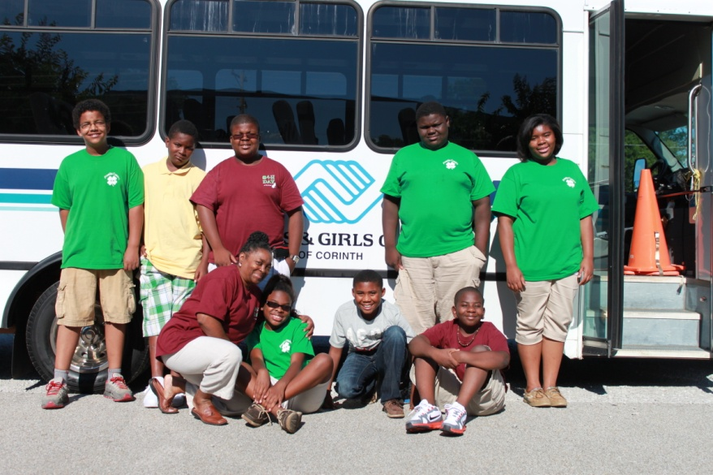

This Summer’s Events

Robotics

Camp Waukaway

Manufacturing Camp

Camp You Choose

Mississippi State Robotics Camp

Returning from robotics competition

Our Summer Program Events Details

“Live in the moment.” –Angelique Jumper

This summer the Booneville Boys & Girls club had many wonderful opportunities for summer programs. They started off with a trip to Vossberg, MS at camp Waukaway and ended at Robotics camp at Mississippi State. The club would like to thank all those who made it possible. Without volunteers and the help of the community, the club would not have the opportunities it had this summer.

The school year will be starting soon, and we hope to have a successful school year. 

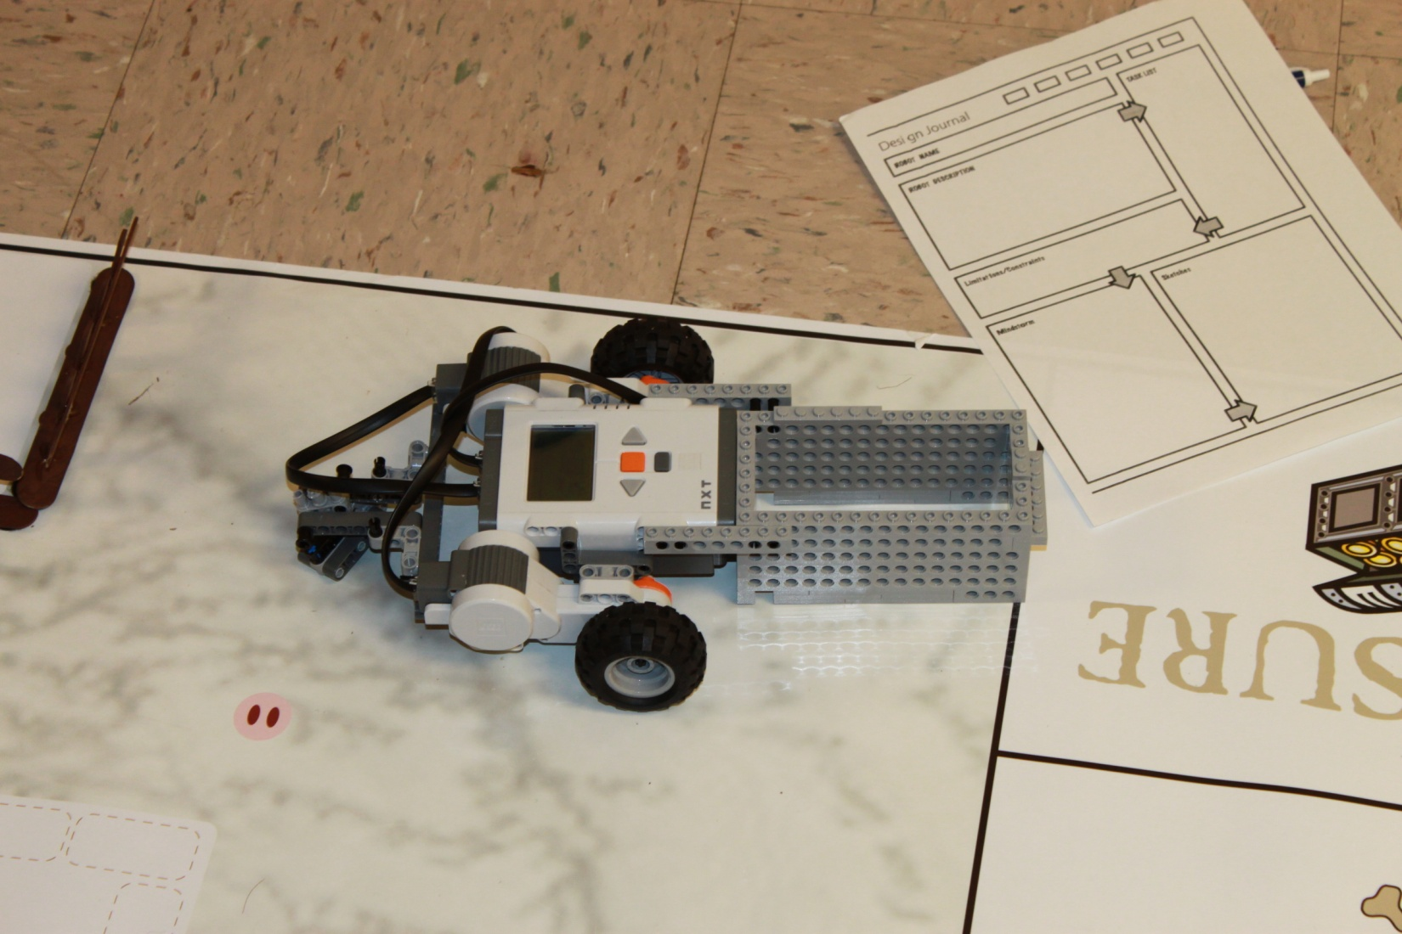

Robotics/Mississippi State Robotics Camp

The children started the robotics program during the school year with the help of 4H.

We had ten students participating this year. During the summer the children in robotics had the opportunity to compete in the 4H club congress competition. Not only did they compete in robotics, but two students also competed in Clothing. Students Tryson Agnew and Thobis Simmons received second and third place in the competition.

At Mississippi State Robotics Camp event director Ms. Mariah had events scheduled everyday all day long with events from building bots, programming, arts and crafts, games, rock climbing, sports, and learning to prepare foods. Each student who participated also got to build a robot to take home.

One of the robots entered into this years competition.

Camp Waukaway

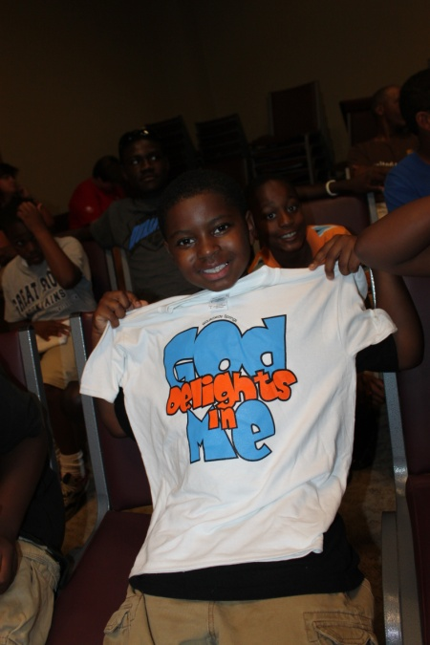

Camp waukaway is always a favorite summer program of the BGCA. The Christian camp located in Vossberg, MS sets aside two days every summer for different non-profit organizations who help children. This year 20 students had the opportunity to attend camp. During the camp kids get to go on a nature walk, learn team building skills, self discovery, self-esteem, and character building.

Each student received a T shirt and Bible

Manufacturing Camp at ICC

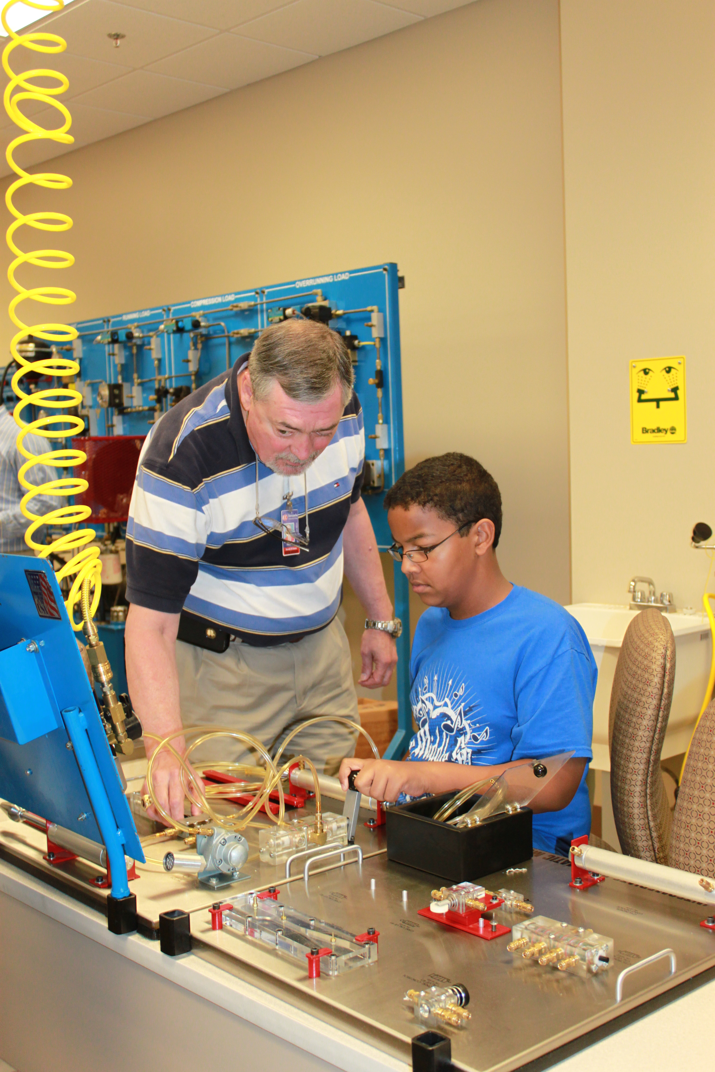

At manufacturing camp the children were given hands on experience on various machines in which they made a metal clock, mini hammer and got to utilize their own computer skills and imagination. They were also able to visit different manufacturers in Tupelo and see how their factories worked.

Caption describing picture or graphic.

Summer 2012 ● Volume 1, Issue 1 ● Booneville BGCA ● (662) 210-0841

Page 2

Camp You Choose/Northeast Workshop

Booneville Boys & Girls Club

Booneville, MS 38829

Phone:

(662) 210-0841

E-Mail:

[ay_msjumper@yahoo.com](mailto:ay_msjumper@yahoo.com)

Web Site:

***boonevillebgca.weebly.com***

The Booneville Boys & Girls Club also offered a camp to its high school students. Camp You Choose was put on by the Tobacco Free Coalition and the Region 4 AOP Group. During the week Alcorn and Prentiss County drama group preformed games and exercises. They also had speakers come in to tell the dangers of alcohol and tobacco.

Our kids’ favorite  
 joke:

How do you make a hanky dance?

Put a little boogie in it!

What’s next?

Boys and Girls Club is looking forward to opening back in September. During that time students will get help with homework, and have the chance to learn life skills. We will also be starting the robotics, upholstery, art, and photography. Our club will also offer tutoring to students who need it. Will also continue our BGCA programs passport to man, smart girls, money management, and triple play.

GREAT FUTURES START HERE



